|  |  |
| --- | --- |
| Name | M.Faizan Azam, Muhammad Asad |
| Reg. # | 2019-EE-381,2019-EE-383 |
| Marks |  |

Experiment # 10

**Active Low Pass and High Pass Filter**

# Objectives:

* To obtain the frequency response of an active low pass and high pass filter for desired cutoff frequency and verify the roll off.

# Apparatus:

Op-amp 741, Capacitors, Resistors, DMM, CRO, Function Generator, Jumpers, Connecting wires, DC source, bread board

# Theory:

***Low Pass Filter:***

A low pass filter is an electronic filter that passes low frequency signals but attenuates signal with frequencies higher than the cutoff frequency. The actual amount of attenuation for each frequency varies from filter to filter. It is sometimes called a high cut filter or treble cut filter when used in audio applications. The frequency response of a low pass filter is shown in fig.

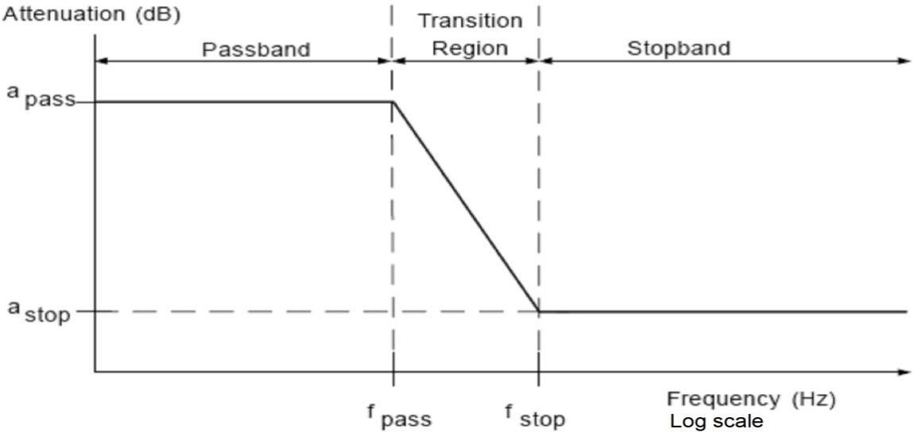

The cutoff frequency and gain in db can be calculated by the following formula as given as

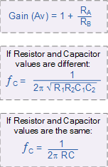

This second order low pass filter circuit has two RC networks, R1 – C1 and R2 – C2 which give the filter its frequency response properties. The filter design is based around a non-inverting op- amp configuration so the filters gain, A will always be greater than 1. Also the op-amp has a high input impedance which means that it can be easily cascaded with other active filter circuits to give more complex filter designs.

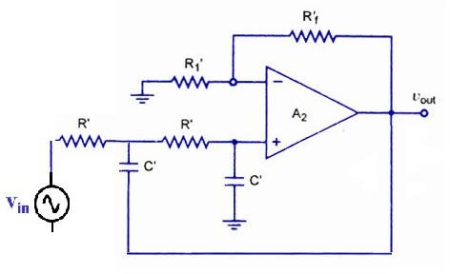

# High Pass Filter:

There is very little difference between the second order low pass filter configuration and the second order high pass filter configuration, the only thing that has changed is the position of the resistors and capacitors as shown in fig.

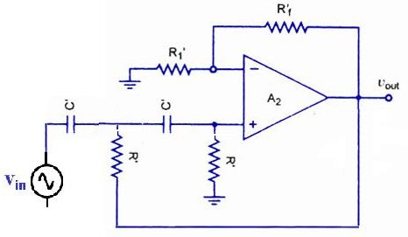

Since second order high pass and low pass filters are the same circuits except that the positions of the resistors and capacitors are interchanged, the design and frequency scaling procedures for the high pass filter are exactly the same as those for the previous low pass filter. Then the bode plot for a 2nd order high pass filter is therefore given as:

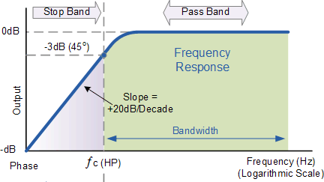

# General Procedure:

***Low pass filter:***

* Setup the circuit as shown above.
* Design the filter for a gain of 1.586 and make the connections as shown in circuit diagram.
* Set the signal generator amplitude to 100 mV (p-p) and observe the input and output voltage on CRO.
* By varying the frequency of input from 50 Hz range to 5 kHz, note down the corresponding output voltage across pin 6 of the op amp with respect to ground.
* The output remain constant for lower frequency range
* Plot the graph with ‘f’ on X-axis and gain in dB on Y-axis.

# High pass filter:

* Setup the circuit as shown above.
* Design the filter for a gain of 1.586 and make the connections as shown in circuit diagram.
* Set the signal generator amplitude to 100 mV (p-p) and observe the input and output voltage on CRO.
* By varying the frequency of input from 50 Hz range to 5 kHz, note down the corresponding output voltage across pin 6 of the op amp with respect to ground.
* The output remain constant for lower frequency range
* Plot the graph with ‘f’ on X-axis and gain in dB on Y-axis.

# Design:

Design the active low pass and high pass filter with given range of frequency and find out the gain and cutoff frequency and draw the graph.

# Circuit:

1. ***Low pass Filter:***

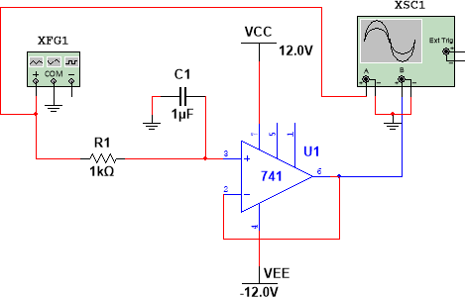

***Calculations:***

fc = 1/2*pi*RC

fc = 1/2*3.14*1000*0.000001 fc = 159.14

***Graph:***

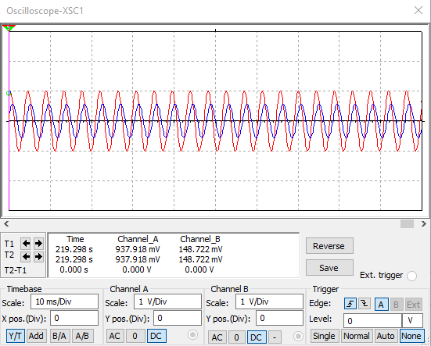

***Result:***

|  |  |  |
| --- | --- | --- |
| Sr.# | **Frequency** | **Gain** |
| 01 | 50 | 1.23mV |
| 02 | 60 | 1.3mV |
| 03 | 70 | 1.22mV |
| 04 | 90 | 1.23mV |
| 05 | 100 | 1.31Mv |
| 06 | 120 | 1.31mV |

1. 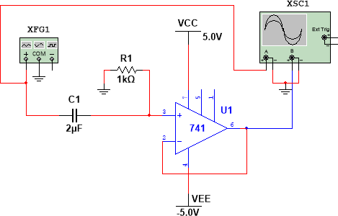***High pass filter:***

***Calculations:***

fc = 1/2*pi*RC

fc = 1/2*3.14*1000*0.000002 fc = 79.14

***Graph:***

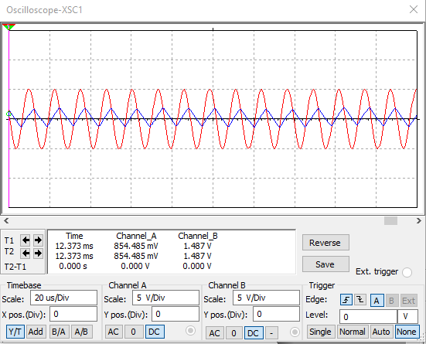

***Result:***

|  |  |  |
| --- | --- | --- |
| Sr.# | **Frequency** | **Gain** |
| 01 | 50 | 1.23mV |
| 02 | 60 | 1.3mV |
| 03 | 70 | 1.22mV |
| 04 | 90 | 1.23mV |
| 05 | 100 | 1.31Mv |
| 06 | 120 | 1.31mV |

***Questions:***

## What determine the bandwidth of low pass filter?

If you consider an ideal low-pass filter with cut-off frequency of fc, all frequencies greater than fc will be removed. Then it's bandwidth is equal to fcHz (from 0 up to fc). The total bandwidth BT is simply twice that: BT=2fc, since we are also considering negative frequencies, from −fc up to fc.

## What limits the bandwidth of an active high pass filter?

Unlike Passive High Pass Filters which have an “infinite” frequency response, the maximum pass band frequency response of an active high pass filter is limited by the open-loop characteristics or bandwidth of the operational amplifier being used, making them appear as if they are band pass filters with a high frequency.

## Why the damping factor is important for filter?

The damping factor is used to exhibit the characteristic response of an active filter circuit by negative feedback action. It is used to find the order of the filter One of the values

of resistor can be calculated with other known value of resistor by using feedback resistor ratio.

## Name the basic components of an active filter?

Active filters are the electronic circuits, which consist of active element like op-amp(s) along with passive elements like resistor(s) and capacitor(s).

In terms of general response, the four basic categories of active filters are low-pass, high- pass, band-pass, and band stop.